Contents

Use Case Diagram 2

Login 3

Bootstrap 4

Delete location via file upload 5

Delete location via UI 5

Basic app usage report (Breakdown by app category) 6

Basic app usage report (Diurnal Pattern) 7

Basic app usage report (Breakdown by usage time category and or demographics) 8

Top-k students or schools with most app usage (given an app category) 9

Top-k most used apps (given a school) 10

Smartphone Overuse Report 11

Smartphone Usage Heatmap 12

Class Diagrams 13

Core Entity 13

Controller and DAO 14

Logical Diagram 15

## Use Case Diagram

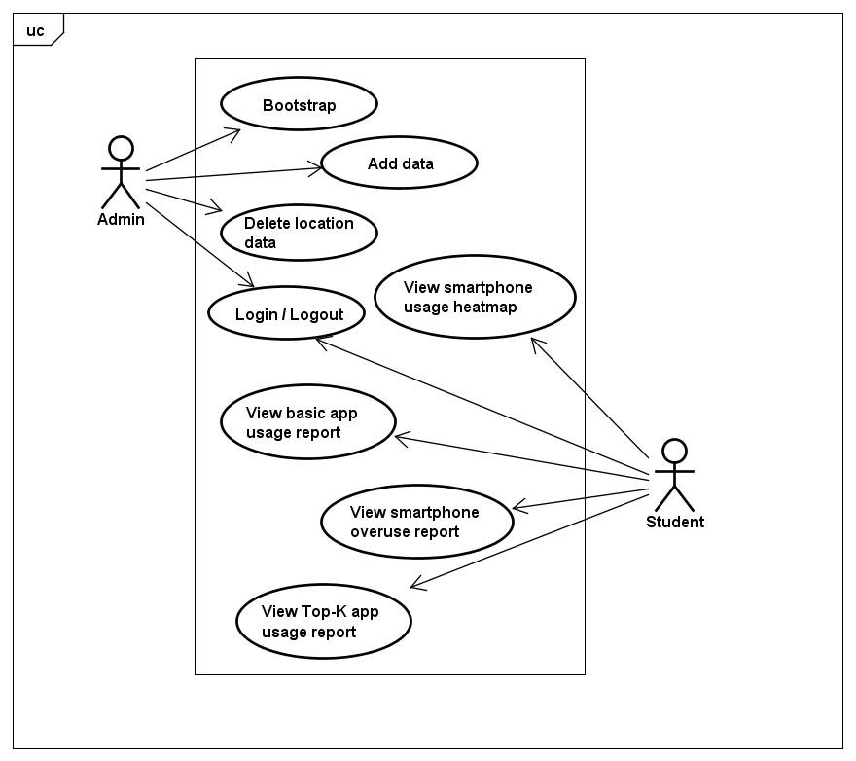

|  |  |
| --- | --- |
| **Use case** | **Description** |
| 1. Login / Logout | Admin and Student can log into and out of the SMUA system with a valid email ID and password. |
| 2. Bootstrap | Admin can bootstrap the SMUA system with app-lookup, app, demographics, location and location-lookup data. |
| 3. Add data | Admin can add new app, demographics and location data while the app is running. |
| 4. Delete location data | Admin can delete a subset of location data through uploading location-delete file or specify details of data to be deleted. |
| 5. View basic app usage report | Student can view the app usage stats breaking down by usage time category, usage time category and demographics, app category and diurnal pattern for any given duration. |
| 6. View Top-K app usage report | Student can view top-k users, apps and schools for any give duration and app category. |
| 7. View smartphone overuse report | Student can see his smartphone overuse index based on smartphone usage time, gaming time and frequency of checking smartphones. |
| 8. View smartphone usage heatmap | Student can view the density of people using smartphone at any given floor in SIS building, date and time. |

Sequence Diagrams

## Login

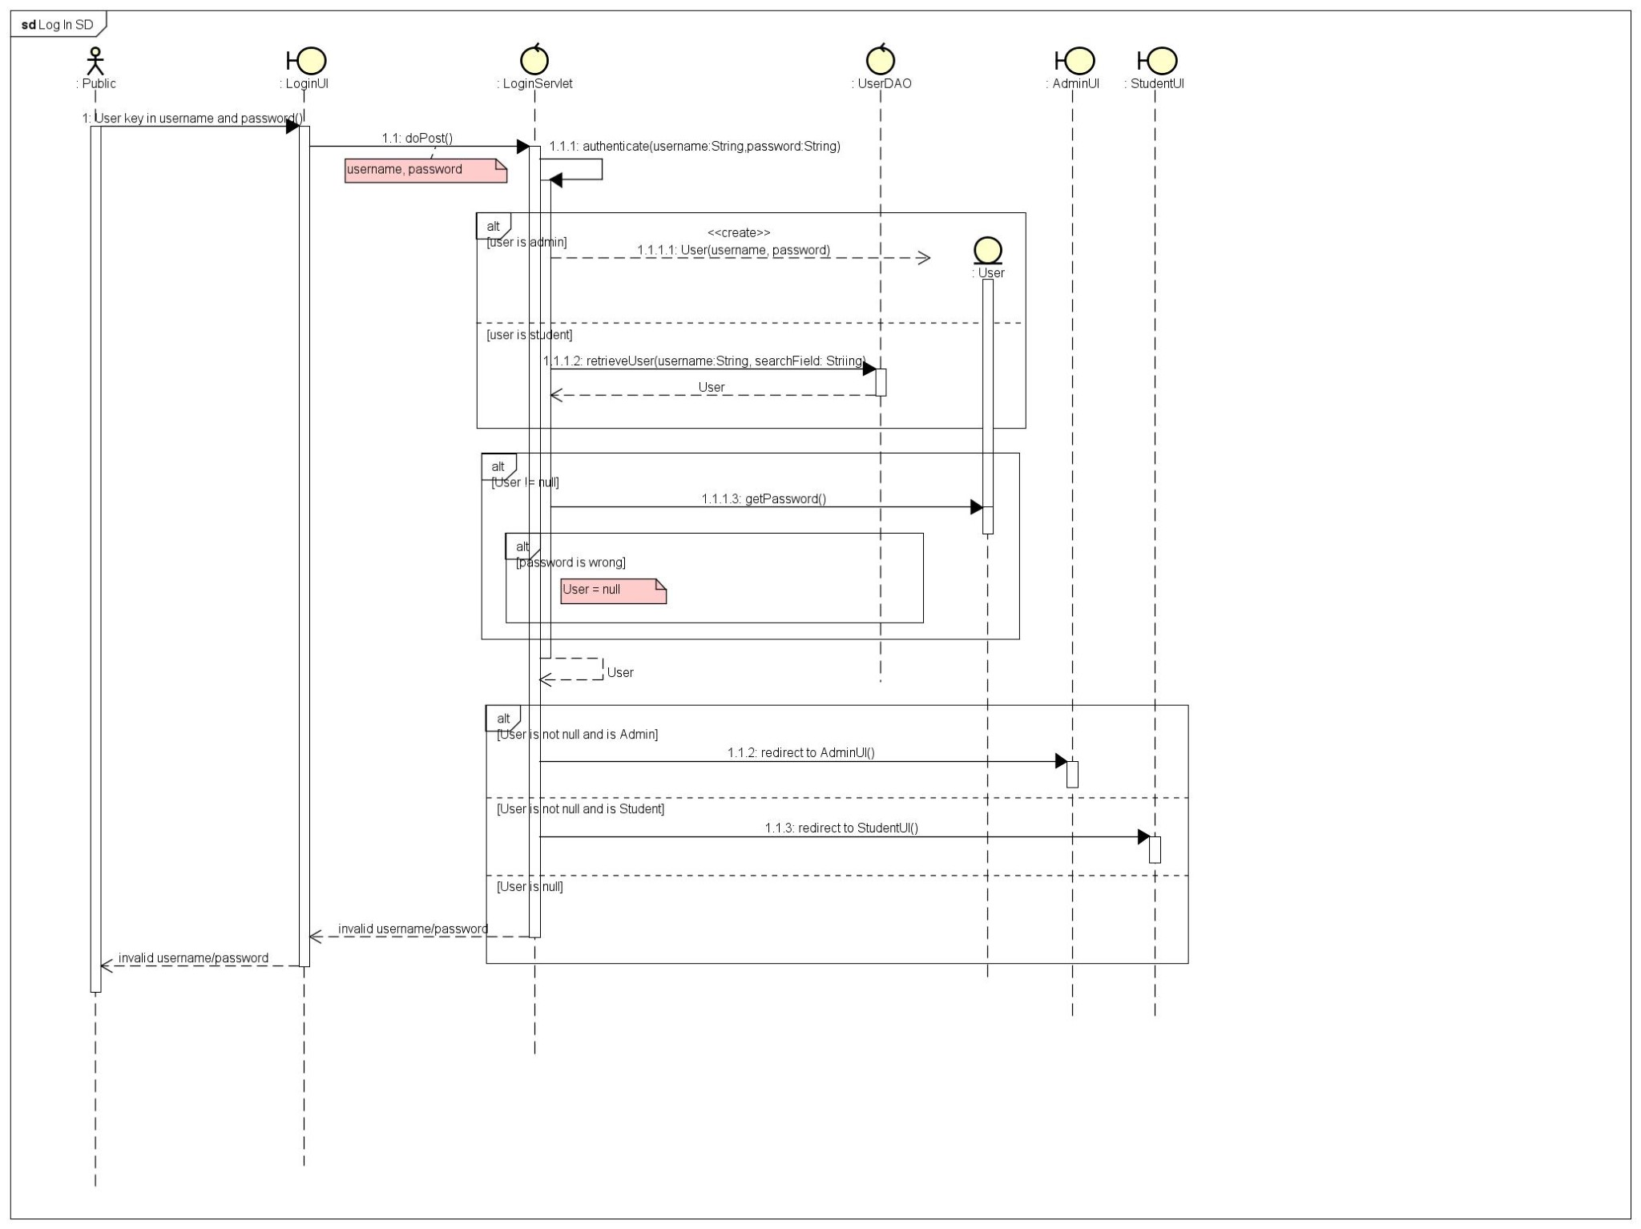

## Bootstrap

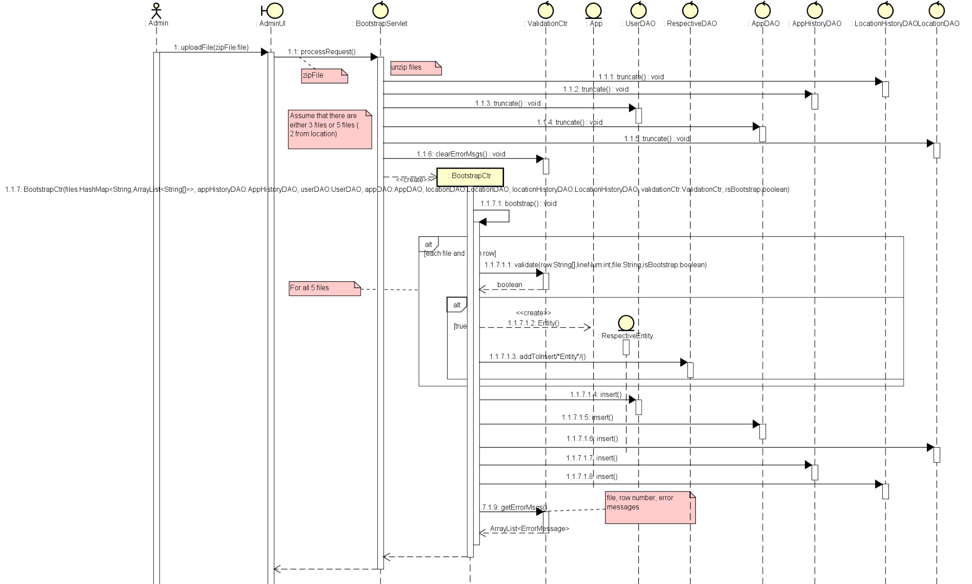

## Delete location via file upload

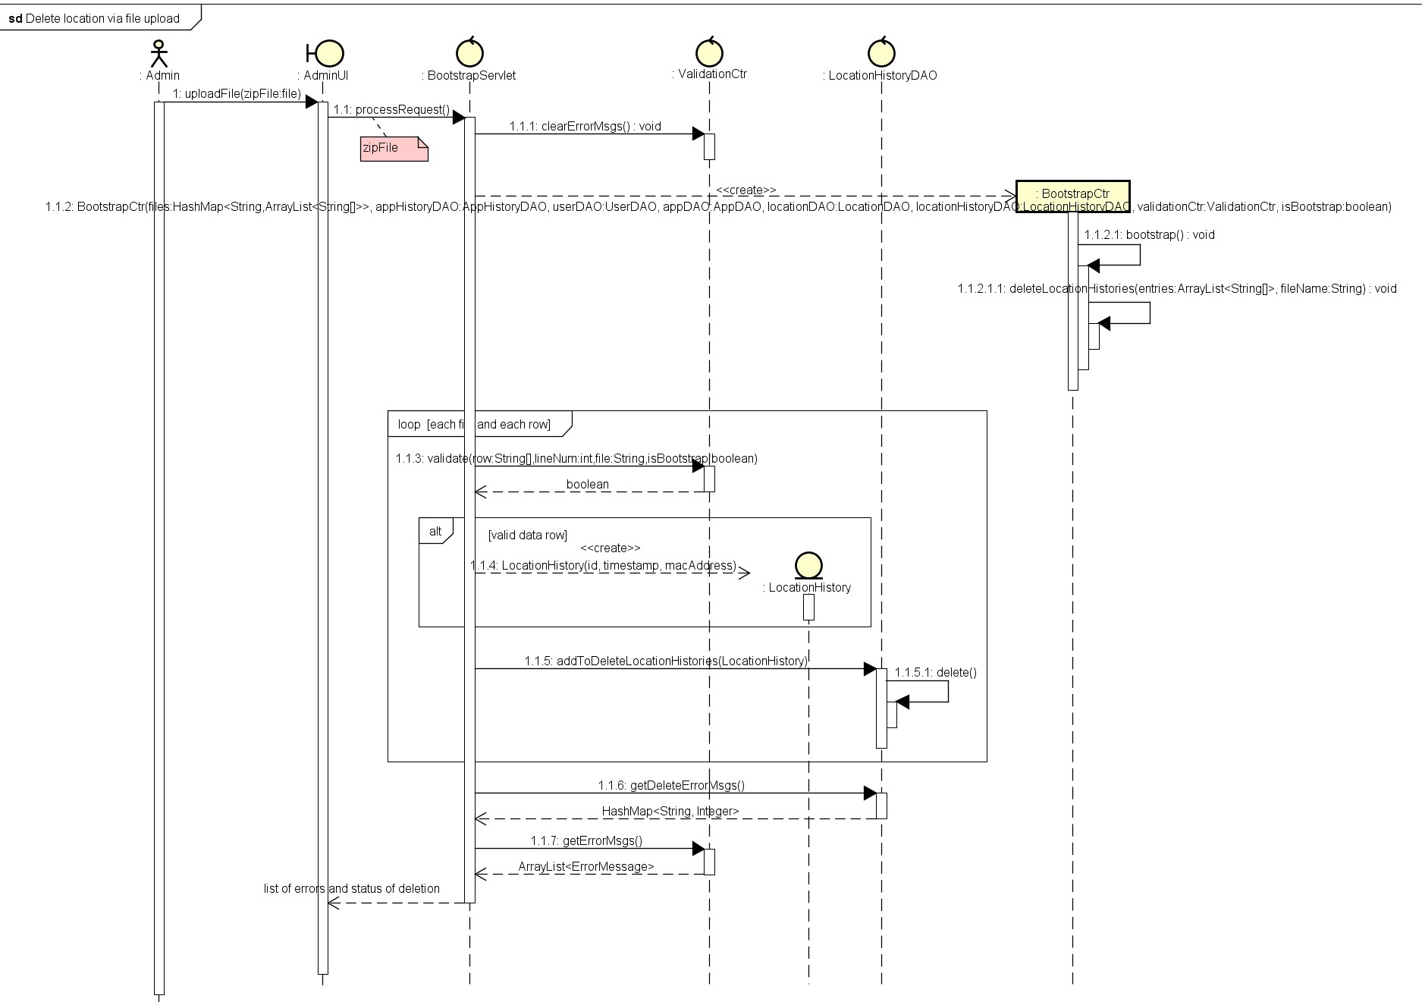

Delete location via UI

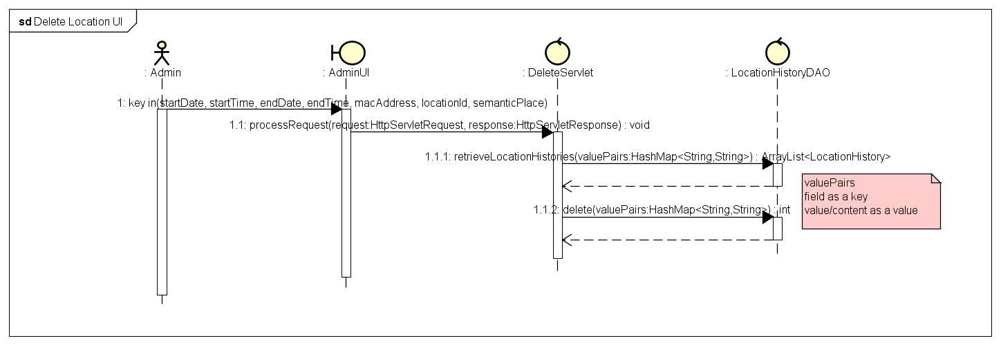

## Basic app usage report (Breakdown by app category)

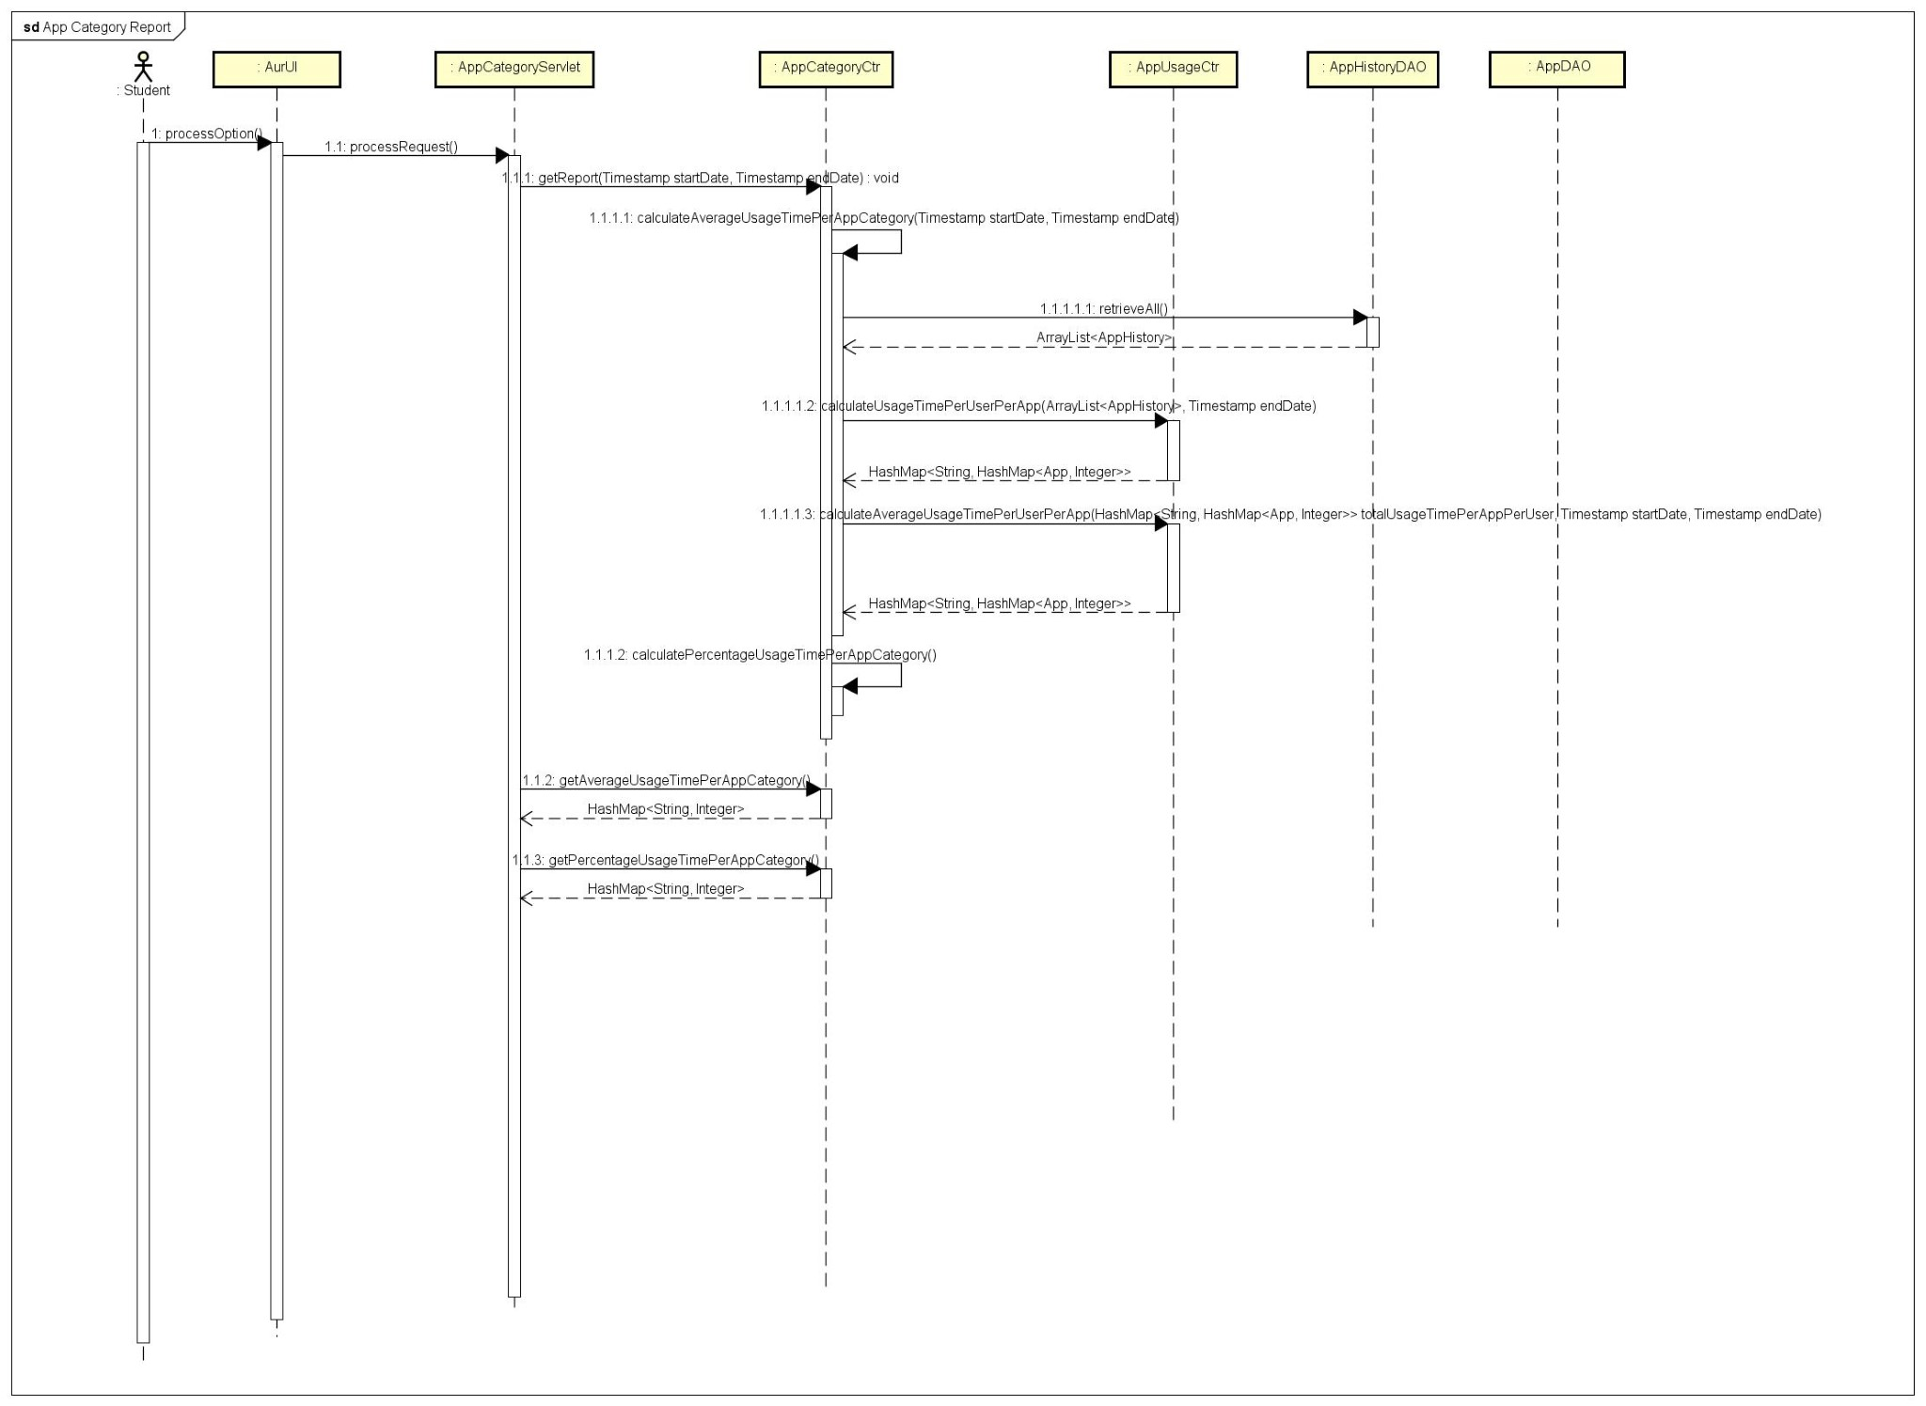

## Basic app usage report (Diurnal Pattern)

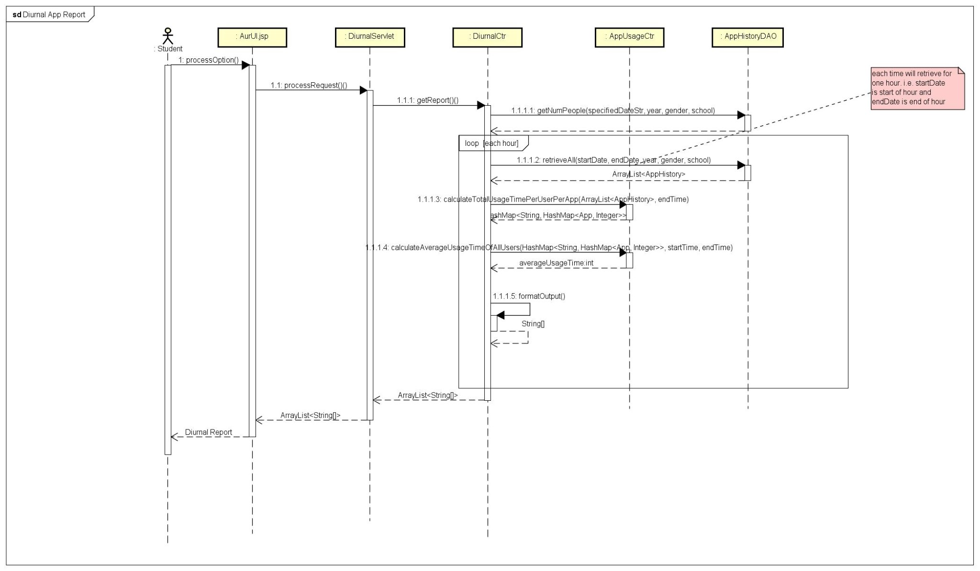

## Basic app usage report (Breakdown by usage time category and or demographics)

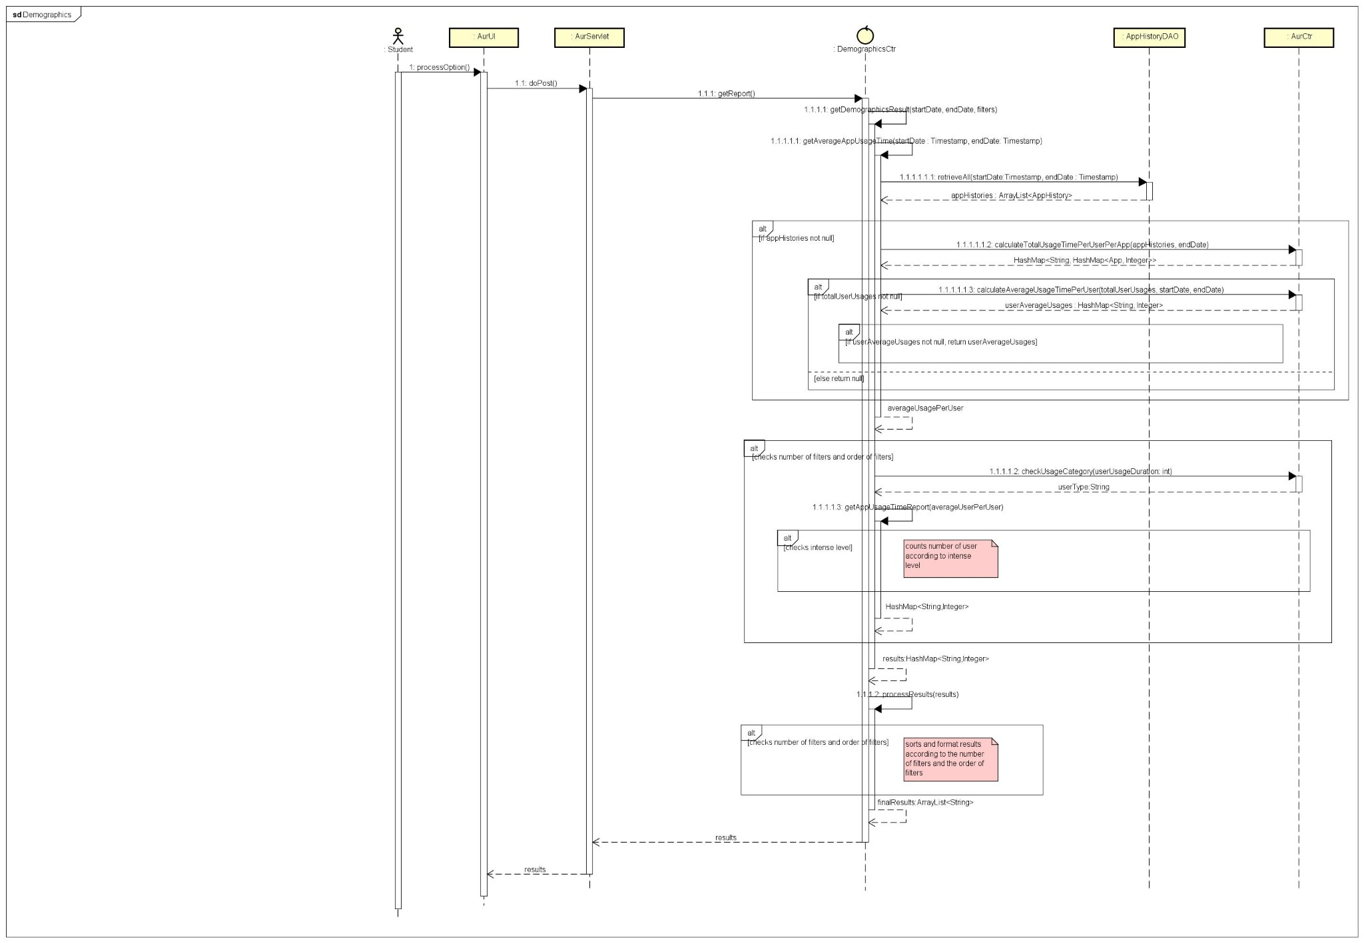

## Top-k students or schools with most app usage (given an app category)

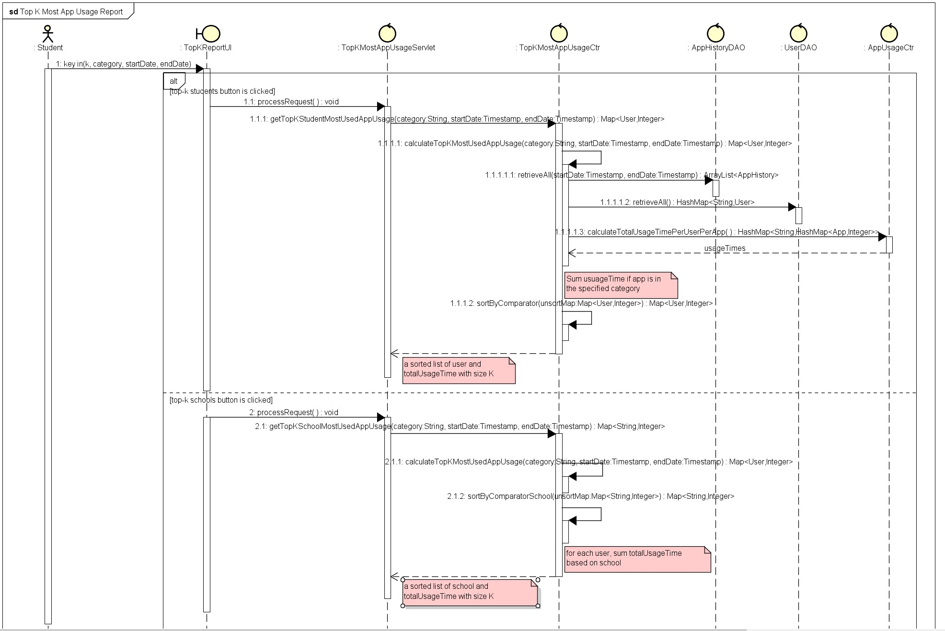

## Top-k most used apps (given a school)

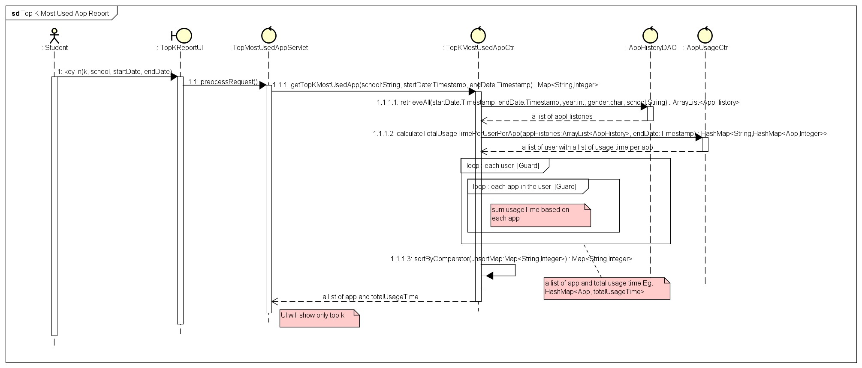

## Smartphone Overuse Report

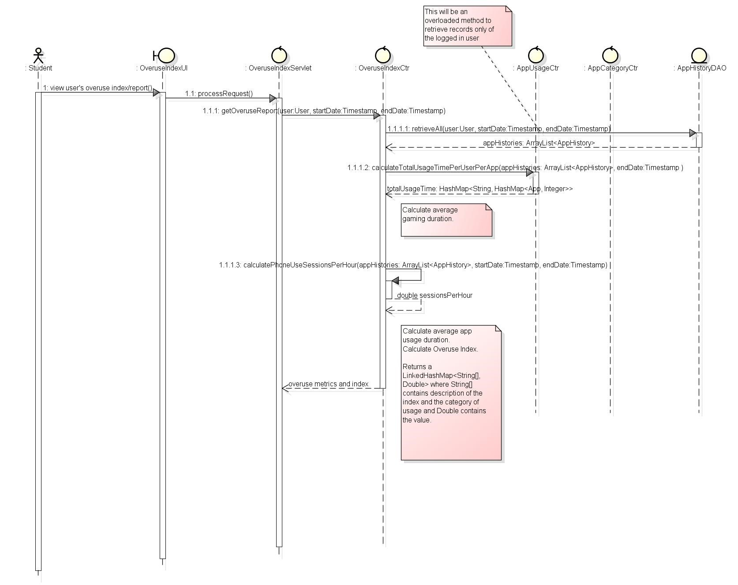

## Smartphone Usage Heatmap

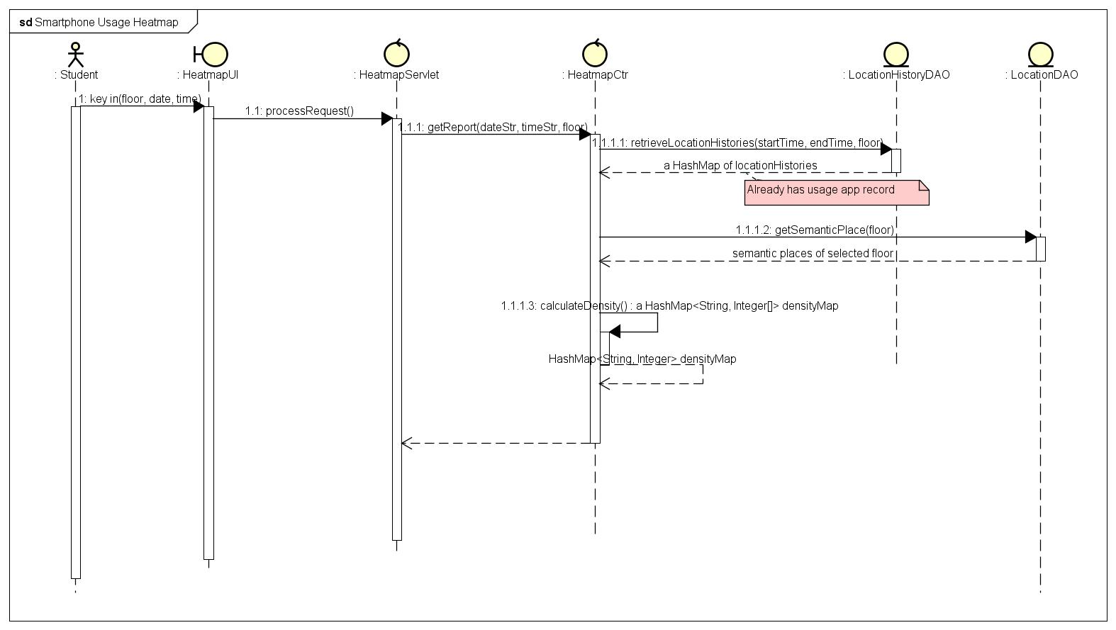

# Class Diagrams

## Core Entity

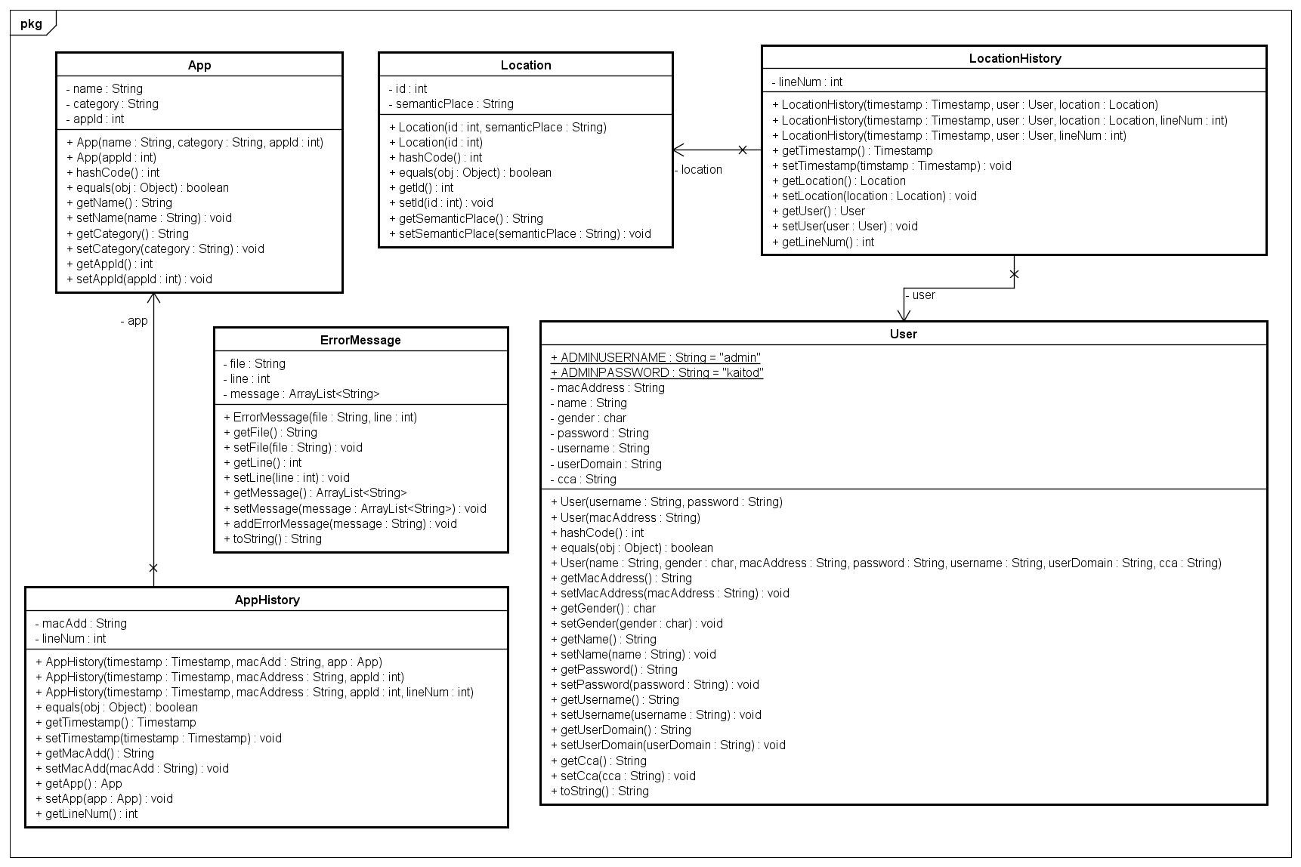

## Controller and DAO

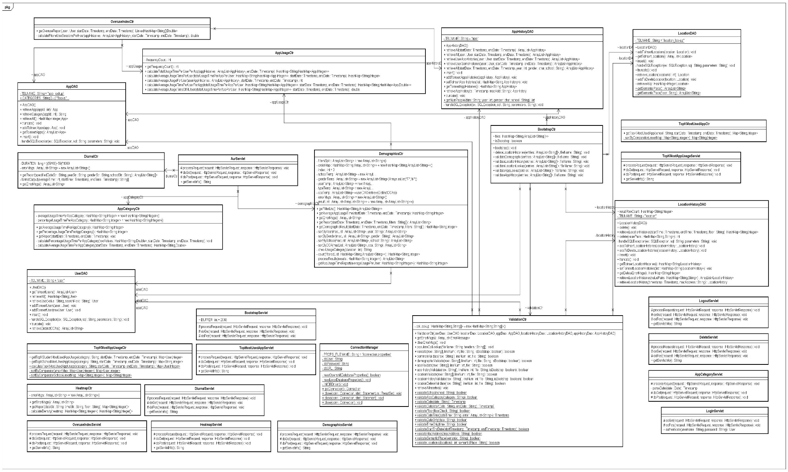

## Logical Diagram

